26/06/2017

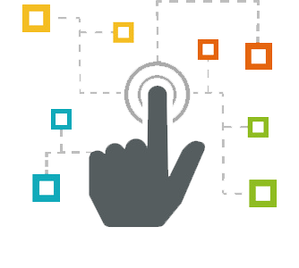

Project Boulder Dash

By Tom Brunetti, Geoffroy De-Felcourt, Thibault Michel et Antoine Masalsky

CESI.Exia

Sommary :

1. Problematic………………………..…………………………………Page 2
2. Presentation of members………………………………………Page 2
3. Provisional and real planner..…………………………………Page 2
4. Daily logbook
5. UML
6. Packages diagram
7. Component diagram
8. Sequences diagram
9. Classes diagram
10. Javadoc
11. JXR
12. Surefire report
13. Git report
14. Data Base
15. Global record
16. Personal record
17. Antoine Masalsky
18. Thibault Michel
19. Tom Brunetti
20. Geoffroy De-Felcourt

# **Problematic:**

Our objective is to recreate an old abandonware called « Boulder Dash ».

The main directive is to use UML and Java languages.

We have too some constraint:

* The levels must be socked in a data base.
* We can’t use another graphic framework than Spring
* We must create a Git project, use the architecture Maven and his plugin JUnit.

# **Presentation of members:**

# **Provisional and real planner**

* Provisional:

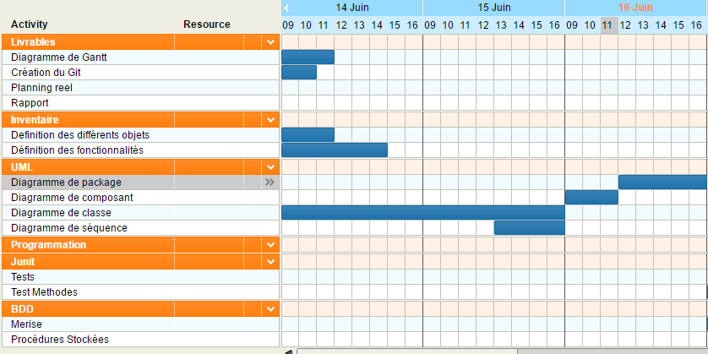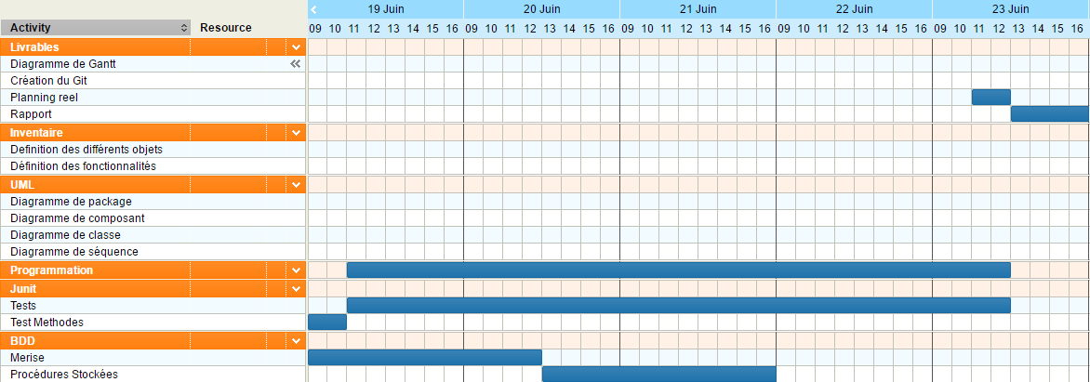

* Real:

# **Daily logbook**

Wednesday June’s 14th:

* Creation and configuration of our Git network
* projected planning
* Creation of the main structure of our program
* Definition of the mains methods
* Creation of component diagram
* Creation of the class diagram

Thursday June’s 15th:

* Final revision for CCTL
* Fix incoherence of component diagram
* Fix incoherence of class diagram
* Fix incoherence of the Git Network
* Creation of the UML diagram
* Creation sequences diagram
* Definition of secondary methods

Friday June’s 16th:

* Finishing of component diagram
* Finishing of class diagram
* Finishing of sequences diagram
* Fix incoherence of UML diagram

Monday June’s 19th

* Starting write project report
* Application of UML’s dependencies in the program
* Creation of the Database and stored procedure
* Decrypting the test program

# **UML**

## Packages Diagram

## Component Diagram

## Sequences Diagram

## Classes Diagram

# **Javadoc**

# **JXR**

# **Surefire report**

# **Git report**

# **Database**

# **Global Bilan**

# **Personal Bilan**

## Antoine Masalsky

## Thibault Michel

## Tom Brunetti

## Geoffroy De-Felcourt